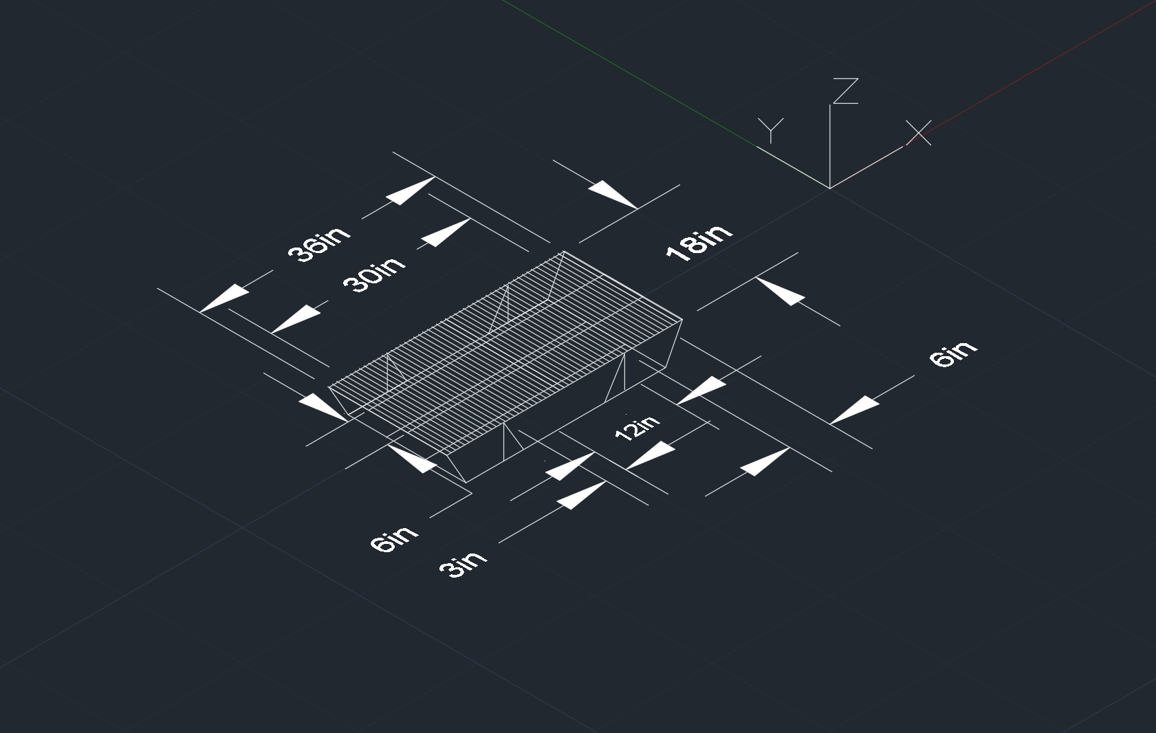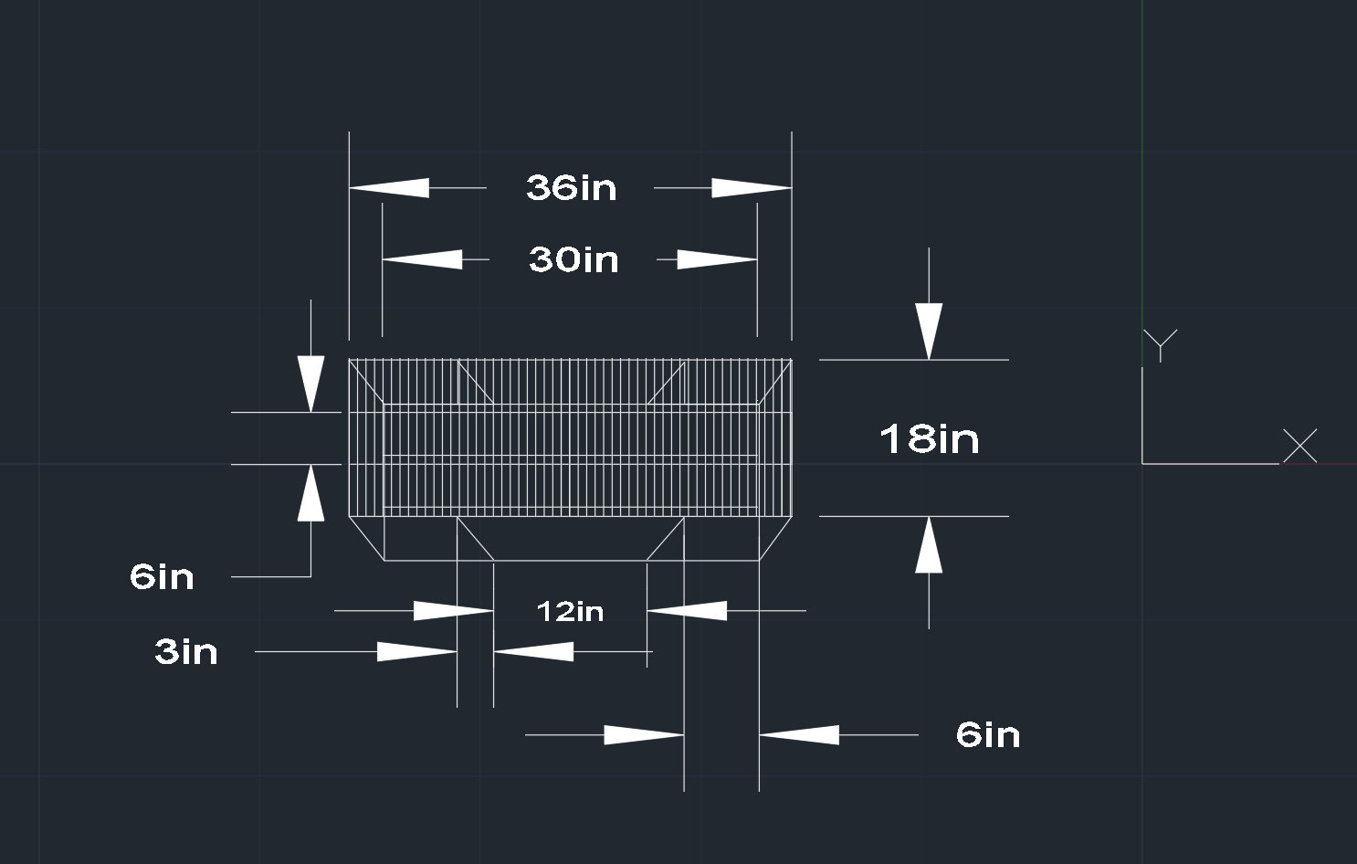

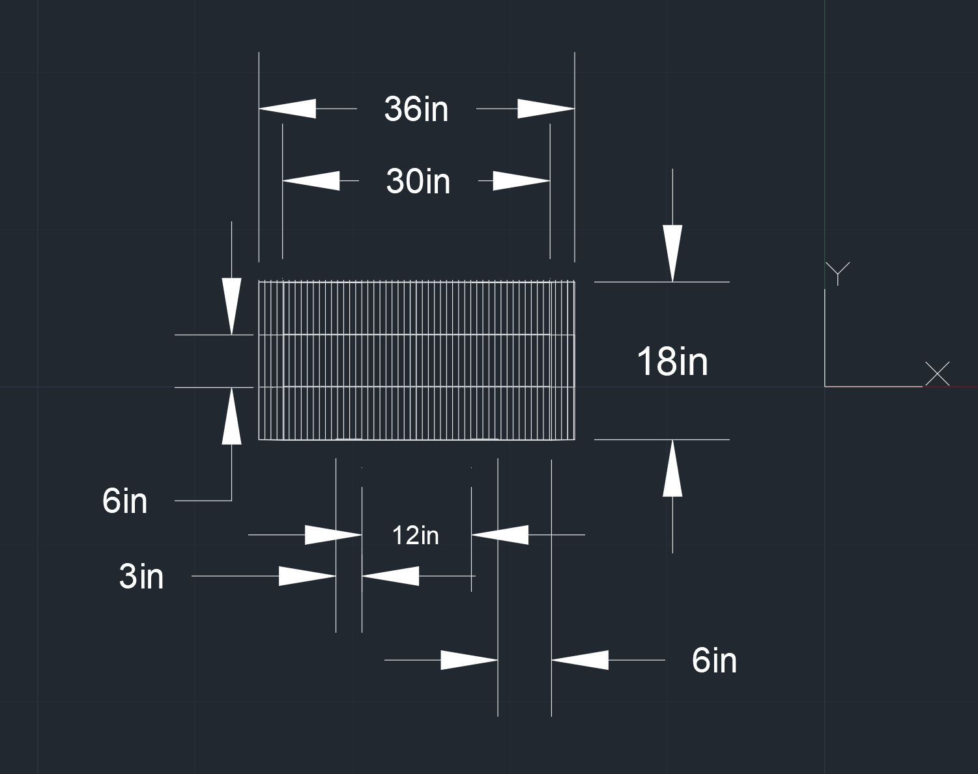

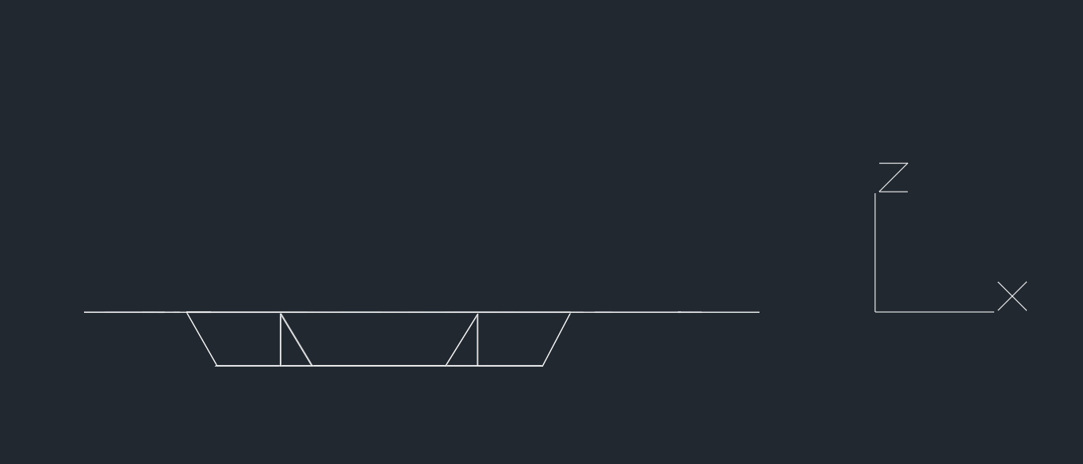



**Popsicle sticks:**

**Top surface – 3 lines of 52 sticks: 156 popsicle sticks**

**Top and Bottom surface support beams – 12 on the top surface, 10 on the bottom, total 22 sticks**

**Frame – 4 angled pieces, two -5 long by 2 thick lower frame pieces, two 3 long by 2 thick lower frame widths, total 36 pieces**

**Triangle Frame Supports – 4 two stick triangles, 8 in total**

**Joints - ~8 popsicle sticks**

**TOTAL: 230 popsicle sticks**

**Measurements for a single popsicle stick to guide this model are 6 inches long by .688 inches wide.**

**This is a simplified version of a truss bridge design. It is simple and compact design. It relies on several triangles contained in a triangle shape, but we cut down the triangles to save sticks. We removed the cable-stayed top to our bridge to save popsicle sticks, and we felt it wasn’t worth the weight and cost to add the support, especially since cable-stayed bridges rely on central anchors where all of the ‘cables’ meet. Additionally, it adds the logistics of having to build the bridge with a wide enough frame to contain the robot, and we felt the trouble isn’t worth it. The frame is two thick interlocking popsicle sticks except for the supports on the bottom section, which are one thick. The top surface is the vast majority of the popsicle sticks.**